St Andrew's Church

Orford with Longford
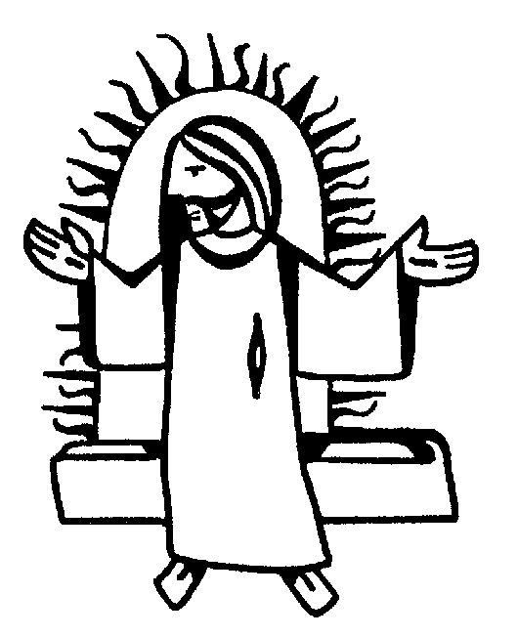

THE FUNERAL SERVICE

for

Beryl Roberts

Wednesday 17th November 2010

Jesus said, “I am the resurrection and I am the life; those who believe in me, though they die, yet shall they live, and whoever lives and believes in me shall never die.”

Beryl Roberts
Reception into Church
16th November 2010

The priest leads the procession into church, reading the sentences from scripture.

Introduction and opening words

Priest: In the name of the Father, and of the Son, and of the Holy Spirit. Amen

We receive the body of our sister Beryl with confidence in God, the giver of life, who raised our Lord Jesus from the dead.

Sprinkling the coffin with water.

The coffin is sprinkled with holy water taken from the font. It is a reminder of baptism and the promise of eternal life that flows from it.

Priest: With this water we call to mind Beryl’s baptism. As Christ went through the deep waters of death for us, so may he bring us to the fullness of resurrection life with Beryl and all the redeemed.

The Paschal Candle is lit to remind us of our Lord’s victory over the power of death.

Priest: Jesus Christ is the light of the world
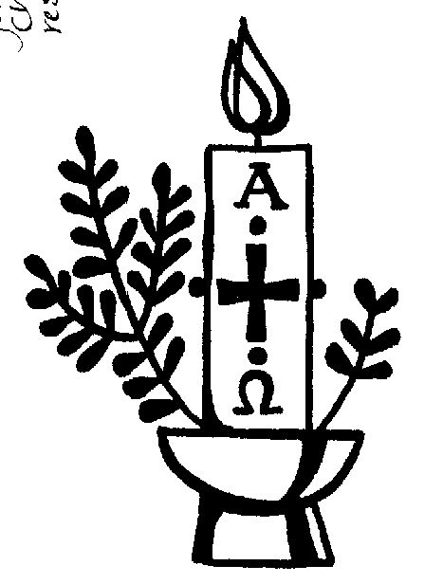
All: a light no darkness can quench

Priest: Stay with us, Lord, for it is evening:
All: and the day is almost over

Priest: Even the darkness is not dark for you:
All: and the night shines like day

Priest: Let your light scatter the darkness:
All: and fill your church with your glory

A reading from the letter to the Romans (verses from chapter 8)

I consider that our present sufferings are not worth comparing with the glory that will be revealed in us. If God is for us, who can be against us? He who did not spare his own Son, but gave him up for us all - how will he not also, along with him, graciously give us all things? Who will bring any charge against those whom God has chosen? It is God who justifies. Who is he that condemns? Christ Jesus, who died - more than that, who was raised to life - is at the right hand of God and is also interceding for us. Who shall separate us from the love of Christ? Shall trouble or hardship or persecution or famine or nakedness or danger or sword? No, in all these things we are more than conquerors through him who loved us. For I am convinced that neither death nor life, neither angels nor principalities nor powers, neither the present nor the future, neither height nor depth, nor anything else in all creation, will be able to separate us from the love of God that is in Christ Jesus our Lord.

This is the word of the Lord
All: Thanks be to God

Verses from Psalm 27

All say together:
1. The Lord is my light and my salvation
whom then shall I fear?
the Lord is the stronghold of my life
of whom shall I be afraid?

4. One thing I have asked from the Lord which I will require
that I may dwell in the house of the Lord
all the days of my life

5. to see the fair beauty of the Lord:
and to seek his will in the temple.

6. For he will hide me under his shelter in the day of trouble
and conceal me in the shadow of his tent
and set me high upon a rock.

8. And I will offer sacrifices in his sanctuary with exultation:
I will sing, I will sing praises to the Lord.

Glory to the Father and to the Son:
and to the Holy Spirit:
As it was in the beginning is now:
and shall be for ever. Amen

The Prayers

Priest: Let us pray:

Prayers for Beryl, her family and friends follow.

The Lord’s Prayer:

Priest: Let us pray for the coming of the Kingdom in the words our Saviour gave us:
All: Our Father, who art in heaven,
hallowed be thy name,
Thy kingdom come, thy will be done,
on earth, as it is in heaven.
Give us this day our daily bread,
and forgive us our trespasses,
as we forgive those who trespass against us.
And lead us not into temptation,
but deliver us from evil.

For thine is the kingdom,
the power and the glory,
for ever and ever. Amen.

A pall is spread over the coffin as John Rutter’s Pie Jesu or other, will be played.

Priest: Let us pray:

We are already God’s children, but what we shall be has not yet been revealed. Yet we know that when Christ appears we shall be like him, for we shall see him as he is.

Keep watch, dear Lord, with those who work, or watch, or weep this night, and give your angels charge over those who sleep. Enfold in your loving arms our sister Beryl who now rests in your eternal peace, and give her rest, this night and always. Amen

Rest eternal grant unto her O Lord
All: And let light perpetual shine upon her. Amen

Priest: May Christ, who out of defeat
brings new hope and a new future,
fill you with his light, his love and his new life;
and the blessing of God almighty
the Father, the Son and the Holy Spirit,
be with you tonight and always. Amen

A Gaelic blessing is played. Please feel free to listen or to leave as you wish.

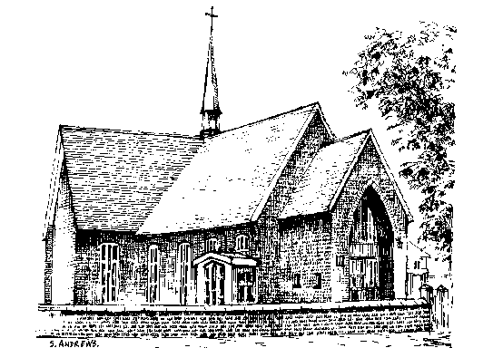The Requiem

17th November 2010

THE GATHERING

Introit Hymn: Angel-voices ever singing
(please stand) round thy throne of light,
angel-harps for ever ringing,
rest not day nor night;
thousands only live to bless thee
and confess thee Lord of might.

Thou who art beyond the farthest
mortal eye can scan,
can it be that thou regardest
songs of sinful man?
can we know that thou art near us,
and wilt hear us? Yea, we can.

Yea, we know that thou rejoicest
o’er each work of thine;
thou didst ears and hands and voices
for thy praise design;
craftsman’s art and music’s measure
for thy pleasure all combine.

In thy house, great God, we offer
of thine own to thee;
and for thine acceptance proffer
all unworthily
hearts and minds and hands and voices
in our choicest psalmody.
Honour, glory, might, and merit
thine shall ever be,
Father, Son and Holy Spirit,
blessed Trinity.
Of the best that thou hast given
earth and heaven render thee.

Priest: We meet in the name of Jesus Christ, who died and was raised to the glory of God the Father. Grace and mercy be with you
All: and also with you.

We have come here today to remember before God our sister Beryl; to give thanks for her life; to commend her to God our merciful redeemer and judge; to commit her body to be buried, and to comfort one another in our grief.

Priest: Let us pray (please remain standing):

Almighty God, you judge us with infinite mercy and justice and love everything you have made. In your mercy turn the darkness of death into the dawn of new life, and the sorrow of parting into the joy of heaven; through our Saviour, Jesus Christ. Amen

Prayers of Penitence

Priest: As children of a loving heavenly Father, let us ask his forgiveness, for he is gentle and full of compassion.

(After a period of silent reflection)
All: Most merciful God, Father of our Lord Jesus Christ, we confess that we have sinned in thought, word and deed. We have not loved you with our whole heart. We have not loved our neighbours as ourselves. In your mercy forgive what we have been, help us to amend what we are, and direct what we shall be; that we may do justly, love mercy, and walk humbly with you, our God. Amen

Priest: Almighty God, who forgives all who truly repent, have mercy upon you, pardon and deliver you from all your sins, confirm and strengthen you in all goodness, and keep you in life eternal; through Jesus Christ our Lord. Amen.

Collect:
Merciful Father, hear our prayers and comfort us; renew our trust in your Son, whom you raised from the dead; strengthen our faith that Beryl and all who have died in the love of Christ will share in his resurrection; who lives and reigns with you, in the unity of the Holy Spirit, one God, now and for ever. Amen

THE LITURGY OF THE WORD

Please sit for
A reading from the first letter of Paul to the Corinthians (1 Cor. 13)

At the end of the reading
Reader: This is the word of the Lord
All: Thanks be to God

Gradual hymn: (please stand)

The Lord's my Shepherd, I'll not want;
he makes me down to lie -
in pastures green; he leadeth me -
the quiet waters by.

My soul he doth restore again,
and me to walk doth make -
within the paths of righteousness,
e'en for his own name's sake.

Yea, though I walk through death's dark vale,
yet will I fear no ill;
for thou art with me, and thy rod -
and staff me comfort still.

My table thou hast furnished
in presence of my foes;
my head thou dost with oil anoint ,
and my cup overflows.

Goodness and mercy all my life
shall surely follow me;
and in God's house, for evermore
my dwelling place shall be.

THE GOSPEL (please remain standing and face the reader)

Priest: Alleluia, alleluia.
God so loved the world that he gave his only Son.
All: Alleluia.

Hear the Gospel of our Lord Jesus Christ according to John (John 6. 35-40)
All: Glory to you, O Lord

At the end
Priest: This is the Gospel of the Lord
All: Praise to you, O Christ

The Address

The Prayers

Priest: Let us pray

Leader: God of mercy, Lord of life, you have made us in your image to reflect your truth and light: we give you thanks for Beryl, for the grace and mercy she received from you, for all that was good in her life, and for the memories we treasure today. Especially we thank you for …

Leader: Lord in your mercy
All: hear our prayer.

Leader: Heavenly Father, you promised eternal life to those who believe. Remember for good this your servant Beryl as we also remember her. Hear our prayers for all who have died, including Arthur and Annie, Sarah, Edward and Gladys. Bring all who rest in Christ into the fullness of your kingdom where sins have been forgiven and death is no more.

Leader: Lord in your mercy
All: hear our prayer.

Leader: Loving Father, your mighty power brings joy out of grief and life out of death. Look in mercy on all who mourn. Give them patient faith in times of darkness. Strengthen them with the knowledge of your love.

Leader: Lord in your mercy,
All: hear our prayer.

Leader: Compassionate Father, you are tender towards your children and your mercy is over all your works. Heal the memories of hurt and failure. Give us the wisdom and grace to use aright the time that is left to us here on earth, to turn to Christ and follow in his steps in the way that leads to everlasting life.

Leader: Lord in your mercy,
All: hear our prayer.

All: God of mercy, entrusting into your hands all that you have made
and rejoicing in our communion with all your faithful people,
we make our prayers through Jesus Christ our Saviour. Amen.

THE LITURGY OF THE SACRAMENT

The Peace (please stand)

Priest: Jesus says: Peace I leave with you; my peace I give to you. Not as the world gives do I give you. Do not let your hearts be troubled, neither let them be afraid. Alleluia.
The peace of the risen Lord be always with you
All: and also with you.

Priest: Let us offer one another a sign of peace.

Offertory Hymn:

On a hill far away stood an old rugged cross,
The emblem of suff'ring and shame;
and I love that old cross where the dearest and best
For a world of lost sinners was slain.
So I'll cherish the old rugged cross
Till my trophies at last I lay down;
I will cling to the old rugged cross
And exchange it some day for a crown.

Oh, the old rugged cross, so despised by the world,
Has a wondrous attraction for me;
For the dear Lamb of God left his glory above
To bear it to dark Calvary.
So I'll cherish the old rugged cross

To the old rugged cross I will ever be true,
Its shame and reproach gladly bear;
Then He'll call me some day to my home far away,
Where his glory for ever I'll share.
So I'll cherish the old rugged cross

EUCHARISTIC PRAYER E (please kneel)

Priest: The Lord is here.
All: His Spirit is with us.

Priest: Lift up your hearts.
All: We lift them to the Lord.

Priest: Let us give thanks to the Lord our God.
All: It is right to give thanks and praise.

Priest: Blessed are you, gracious God, creator of heaven and earth, giver of life, and conqueror of death. By his death on the cross, your Son Jesus Christ offered the one true sacrifice for sin, breaking the power of evil and putting death to flight. With all your saints
All: we give you thanks and praise.

Priest: Through his resurrection from the dead you have given us new birth into a living hope, into an inheritance which is imperishable, undefiled, and unfading. With all your saints
All: we give you thanks and praise.

Priest: The joy of resurrection fills the universe, and so we join with angels and archangels, with Beryl and all your faithful people, evermore praising you and saying:
All: Holy, holy, holy Lord, God of power and might, heaven and earth are full of your glory. Hosanna in the highest. Blessed is he who comes in the name of the Lord. Hosanna in the highest.

Priest: We praise and bless you, loving Father, through Jesus Christ, our Lord; and as we obey his command, send your Holy Spirit, that broken bread and wine outpoured may be for us the body and blood of your dear Son.

On the night before he died he had supper with his friends and, taking bread, he praised you. He broke the bread, gave it to them and said: Take, eat; this is my body which is given for you; do this in remembrance of me.

When supper was ended he took the cup of wine. Again he praised you, gave it to them and said: Drink this, all of you; this is my blood of the new covenant, which is shed for you and for many for the forgiveness of sins. Do this, as often as you drink it, in remembrance of me.

So, Father, we remember all that Jesus did, in him we plead with confidence his sacrifice made once for all upon the cross. Bringing before you the bread of life and cup of salvation, we proclaim his death and resurrection until he comes in glory.

Priest: Praise to you, Lord Jesus:
All: Dying you destroyed our death, rising you restored our life:
Lord Jesus, come in glory.

Priest: Lord of all life, help us to work together for that day when your kingdom comes and justice and mercy will be seen in all the earth. Look with favour on your people, gather us in your loving arms and bring us with St Andrew and all the saints to feast at your table in heaven. Through Christ, and with Christ, and in Christ, in the unity of the Holy Spirit, all honour and glory are yours, O loving Father, for ever and ever.
All: Amen.

Priest: Let us pray with confidence as our Saviour taught us
All: Our Father, who art in heaven, hallowed be thy name; thy kingdom come; thy will be done; on earth as it is in heaven. Give us this day our daily bread. And forgive us our trespasses, as we forgive those who trespass against us. And lead us not into temptation; but deliver us from evil. For thine is the kingdom, the power and the glory, for ever and ever. Amen.

Priest: Every time we eat this bread and drink this cup,
All: we proclaim the Lord’s death until he comes.

All: Lamb of God, you take away the sin of the world, have mercy on us.
Lamb of God, you take away the sin of the world, have mercy on us.
Lamb of God, you take away the sin of the world, grant us peace.

Priest: Jesus is the Lamb of God who takes away the sin of the world.
Happy are those who are called to his supper.
All: Lord, I am not worthy to receive you, but only say the word and I shall be healed.

Holy Communion is administered at the front of Church. Everyone is warmly invited to receive Holy Communion at this Eucharist. Those who prefer to receive a blessing are also invited to come forward at the same time.

Hymn during Communion:

Make me a channel of your peace.
Where there is hatred let me bring your love.
where there is injury, your pardon, Lord,
and where there's doubt, true faith in you.

Oh Master, grant that I may never seek
so much to be consoled as to console,
to be understood, as to understand,
to be loved, as to love with all my soul.

Make me a channel of your peace.
Where there's despair in life, let me bring hope.
Where there is darkness, only light,
and where there's sadness, ever joy.

Oh Master, grant that I may never seek
so much to be consoled as to console,
to be understood, as to understand,
to be loved, as to love with all my soul.

Make me a channel of your peace.
It is in pardoning that we are pardoned,
in giving of ourselves that we receive,
and in dying that we're born to eternal life.

Prayer After Communion:

Priest: Let us pray: Gracious God, we thank you that in your great love you have fed us with the spiritual food and drink of the body and blood of your Son Jesus Christ and have given us a foretaste of your heavenly banquet: grant that this sacrament may be to us a comfort in affliction and a pledge of our inheritance in that kingdom where there is no death, neither sorrow nor crying, but fullness of joy with all your saints; through Jesus Christ our Saviour. Amen

All: Heavenly Father, in your Son Jesus Christ you have given us a true faith and a sure hope. Strengthen this faith and hope in us all our days that we may live as those who believe in the communion of saints, the forgiveness of sins and the resurrection to eternal life; through Jesus Christ our Lord. Amen.

Hymn: (during which the pall is removed)

Thine be the glory, risen, conquering Son,
endless is the victory thou o'er death has won;
angels in bright raiment rolled the stone away,
kept the folded grave-clothes where thy body lay.
Thine be the glory, risen, conquering Son,
endless is the victory thou o'er death hast won.

Lo, Jesus meets us, risen from the tomb;
lovingly he greets us, scatters fear and gloom;
let the Church with gladness hymns of triumph sing,
for her Lord now liveth, death hath lost its sting:

No more we doubt thee, glorious Prince of Life;
life is naught without thee: aid us in our strife;
make us more than conquerors through thy deathless love;
bring us safe through Jordan to thy home above.

The Commendation

Priest: Let us commend Beryl to the mercy of God our maker and redeemer.

[Silence is kept]

Priest: God our creator and redeemer, by your power Christ conquered death and entered into glory. Confident of his victory and claiming his promises, we entrust Beryl to your mercy in the name of Jesus our Lord, who died and is alive and reigns with you, now and for ever. Amen

The Nunc Dimittis is read as the procession leaves the church.

The service continues at Walton Lea Crematorium and will be followed by a gathering and Hot Pot at Emmaus Church on Capesthorne Road. Please feel free to come to Walton Lea or not as you choose. If you wish to make your way to Emmaus after the church service, there are sketch maps available to show the way.

Acknowledgement: Common Worship: Pastoral Services, material from which is included in this service, is copyright © The Archbishops’ Council (2000)

First (epistle) reading for the funeral of Beryl Roberts

A reading from the first letter to the Corinthians

I may speak in tongues of men or of angels, but if I am without love, I am a sounding gong or a clanging cymbal. I may have the gift of prophecy, and know every hidden truth; I may have faith strong enough to move mountains; but if I have no love, I am nothing. I may dole out all I possess… but if I have no love, I am none the better.

Love is patient; love is kind and envies no one. Love is never boastful, nor conceited, nor rude; never selfish, not quick to take offence. Love keeps no score of wrongs; does not gloat over other men's sins, but delights in the truth. There is nothing love cannot face; there is no limit to its faith, its hope, and its endurance.

Love will never come to an end.
Are there prophets? their work will be over.
Are there tongues of ecstasy? they will cease.
Is there knowledge? it will vanish away; for our knowledge and our prophecy alike are partial, and the partial vanishes when wholeness comes.

When I was a child, my speech, my outlook, and my thoughts were all childish. When I grew up, I had finished with childish things. Now we see only puzzling reflections in a mirror, but then we shall see face to face. My knowledge now is partial; then it will be whole, like God's knowledge of me.

In a word, there are three things that last for ever: faith, hope, and love; and the greatest of them all is love.

Reader: This is the word of the Lord
All: Thanks be to God
Gospel reading for the funeral of Beryl Roberts

Priest: Alleluia, alleluia.
God so loved the world that he gave his only Son.
All: Alleluia.

Hear the Gospel of our Lord Jesus Christ according to John
All: Glory to you, O Lord

Then Jesus declared, "I am the bread of life. He who comes to me will never go hungry, and he who believes in me will never be thirsty. But as I told you, you have seen me and still you do not believe. All that the Father gives me will come to me, and whoever comes to me I will never drive away. For I have come down from heaven not to do my will but to do the will of him who sent me. And this is the will of him who sent me - that I shall lose none of all that he has given me, but raise them up at the last day. For my Father's will is that everyone who looks to the Son and believes in him shall have eternal life, and I will raise him up at the last day."

Priest: This is the Gospel of the Lord
All: Praise to you, O Christ

Prayers for use at the Reception of the Body into Church:

Blessed be the God and Father of our Lord Jesus Christ,
who has blessed us all with the gift of this earthly life
and has given to our sister Beryl
her span of years and gifts of character.
God our Father, we thank you now for all her life,
for every memory of love and joy,
for every good deed done by her
and every sorrow shared with us.
We thank you for her life and for her death,
we thank you for the rest in Christ she now enjoys,
we thank you for giving her to us,
and we thank you for the glory we shall share together.
We ask this in the name of Jesus Christ our Lord. Amen

Visit we pray Lord, this your family, and guard with your watchful tenderness the hearts which have been hallowed by your sacred mysteries; that as by your mercy we receive the healing grace of salvation, so by your power and protection we may ever retain them; through Jesus Christ our Lord. Amen

Almighty God, Father of all mercies and giver of all comfort: deal graciously we pray with those who mourn, that casting all their care on you, they may know the consolation of your love; through Jesus Christ our Saviour. Amen

Amendments to be sent to Co-op:

1. Donations to St Andrew’s Church

2. Time of main service around lunchtime to allow family time to travel.

Beryl Roberts

I’m sure that many of you will know that Beryl made all her arrangements for her funeral well in advance. Late last year, everything was complete and she said she felt a lot better for having done so. Among the things she’d done was to ask Gerry to write her eulogy – I’m told the newspapers do it all the time for figures of national importance. After several drafts, Beryl gave her approval and I’d like to read it now, just as it was written:

Beryl was born on 3 February 1941 at 12 Bluecoat Street, only child of Annie and Arthur Roberts. She first walked with St. Ann’s Church, Winwick Road when she was four years of age and attended Sunday School and Church regularly.

Beryl had her first piano lesson at the age of eight and two years later played several pieces for the crowning of the Rose Queen. Beryl was proving to be a naturally gifted musician and in 1952, at the age of eleven, she played for the children’s service on Ash Wednesday – Beryl’s first service! Shortly afterwards, Beryl became deputy organist at St Ann’s and she would often come out of school to play at funeral services. Every fourth Sunday, Beryl also played at the Sunday Services when Eric Woolley, the church organist, was at work.

Beryl was prepared for confirmation at St Ann’s and was confirmed at St Paul’s on 9th January 1955. Beryl remained at St Ann’s until 1980 when she accepted the offer of becoming resident organist at St Andrew’s Church in Orford. She also played at weddings, funerals and services at several other Warrington churches. Sadly, due to poor health, Beryl retired from her post in 1994 and worsening arthritis meant the end of her church activities.

In addition to her commitment to church music, Beryl was also committed to passing on her knowledge and skills to others. By the age of fifteen, Beryl was a qualified music teacher, with an Associated Diploma in Music from the Victoria College of Music. She later gained a teaching certificate from the Victoria College of Music and this was followed by an Honorary Membership Award in 1990. Beryl was also a member of the Organist and Choirmasters’ Association.

Despite having a plate fitted in her neck in 1995, suffering five mini strokes in 1996, losing her father in 1999, and losing her leg in 2000, Beryl maintained her unwavering devotion to music and continued to tutor her pupils until 2006 when she retired.

In recognition of her contribution to the musical world and the fifty years spent teaching pianoforte and music theory, Beryl was invited to attend a special award ceremony at Bold Street Methodist Church. Beryl was presented with a Georgian cut glass vase and twelve red roses by Robin Wood, Doctor of Music and Chief Executive Officer of the Victoria College of Music.

Having spent a lifetime involved in music, Beryl would no doubt want to say:
“Come on everybody! – Sing up! This is a celebration of my life!”

That was Beryl, and I have to say I can hear her saying it even now.

Thinking about the reading from the letter to the Corinthians, which is all about love, there were three great loves in Beryl’s life – God, her music and her family and friends – and all were interwoven. She accompanied more services than I’d had hot dinners – Beryl’s words again – and faithfully played here and at St Ann’s since childhood. It was underpinned by a deep faith and after Beryl could no longer get to church, received the sacrament of Holy Communion at home, which is one of the principle reasons for setting today’s service in a celebration of Communion.

Family too was central to all that Beryl was. She grew up with parents, grandparents and aunts and they were constantly in mind. Anniversaries rolled off her tongue and Beryl had a fascinating way of linking them all by date and time. I wouldn’t be surprised that Beryl’s own death was the same date, or exactly so many months, after that of one of her forebears. We rejoice that she now shares with them in God’s eternal kingdom.

Beryl’s whole life revolved around her music and she has taught and encouraged her many pupils over a lifetime’s tuition. Perhaps the most remarkable thing of all, and some of Beryl’s pupils have gone on to academic and professional careers, is that many of them became lifelong friends, along with their parents. It was largely to their support, particularly over the past ten years, that Beryl was able to live a relatively independent life. Beryl knew this and was thankful for all the support she received. In a moment, Denis Collins, minister at Emmaus Church, father to one of Beryl’s distinguished pupils and above all friend and supporter, will share some of his reflections with us. But just before he does, I’d like to say that Beryl gave generously, just as she received. She supported a number of friends by phone – Beryl’s lifeline to the outside world – especially those who lived alone.

Denis:

